After replace the battery(CR1220),if the 104 alarm still, you need do the following steps.if no alarm ,no need do this.

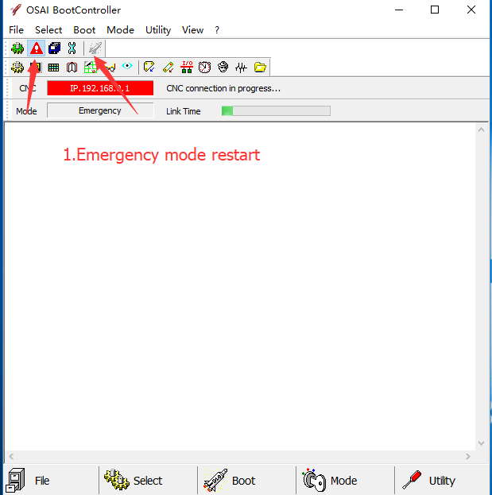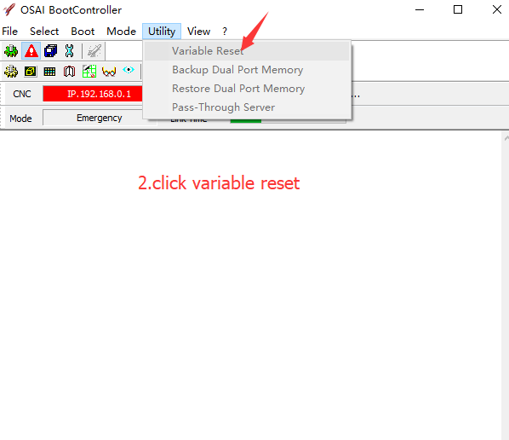

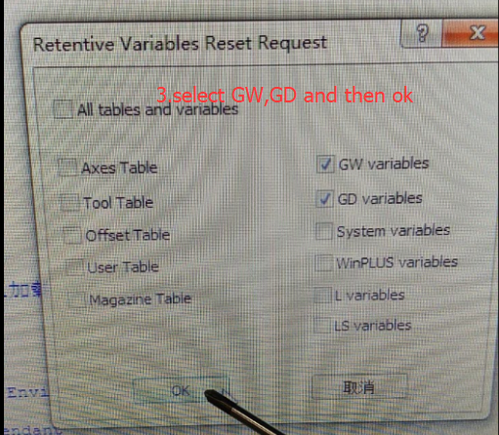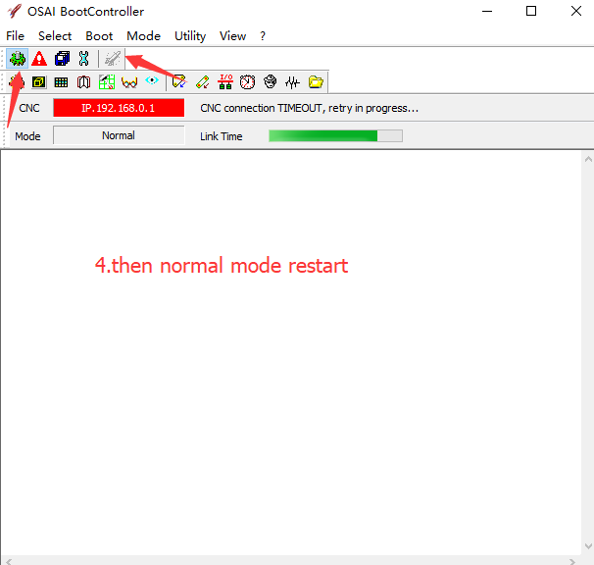
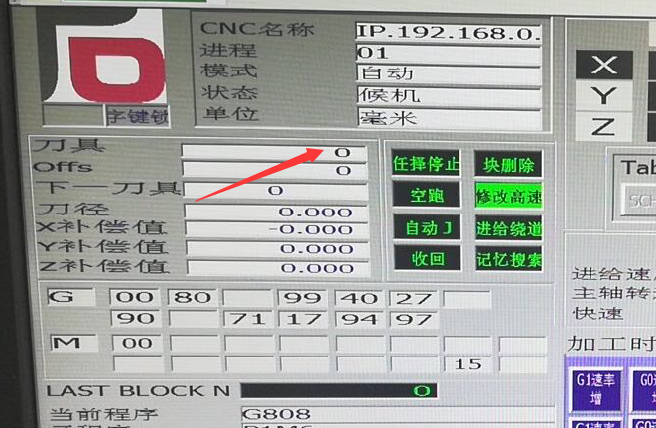
5.After reatart you will find the tool number is 0 ,so you need release the tool from spindle and install to the tool magazine.

